THE PRESIDENT’S OFFICE
REGIONAL ADMINISTRATION AND LOCAL GOVERNMENT
FORM TWO JOINT EXAMINATION FOR GOVERNMENT SCHOOLS – JEGOS


PRE-MOCK EXAMINATION
061 COMMERCE
MARKING SCHEME 2024
SECTION A (15 Marks)
- Multiple choice items;
QN. | i | ii | iii | iv | v | vi | vii | viii | ix | x
Answer | B$√$ | D$√$ | B$√$ | D$√$ | C$√$ | B$√$ | B$√$ | D$√$ | C$√$ | C$√$
10 Ticks @ 1 mark = Total (10 marks)
- Matching items;
Column A | i | ii | iii | iv | v
Column B | G$√$ | F$√$ | E$√$ | A$√$ | D$√$
5 Ticks @ 1 mark = Total (5 marks)

SECTION B (70 Marks)
- Short notes;
- E-tailing
This means buying and selling goods and services by using internet.it is among modern trends in retailing that enables sellers to expand their markets and hence growth.√
- Price tag.
Is the label that shows the price of the particular good sold which is normally clearly indicated.√
- Impulse buying
S thee habit of buyers to buy goods or services as motivated/influenced by the good arrangement rather than planning to do so. This is very common in supermarkets.√
- Cheap jacks
These are small scale retailers who allocate their selling points by moving from one place to another where there is a prospect of customers to pass. They are very common during graduation ceremonies, Christmas days near churches, communion days near churches. They deal with light goods like congratulation cards, ornaments etc.√
- Branding
Is a process of giving a particular name to a product. It involves specific names, labels, or trademarks by a producer to help in order to distinguish them from similar goods of other manufacturers. Brand names must be registered with the government.
For example mbuni, komoa, foma, jamaa and others are soap brands in Tanzania. √
5 Ticks @ 2 marks = Total (10 marks)
- Importance of transport;
- Promote foreign trade
- Develop regions
- Provide employments
- Creates place utility
- Provide varieties of goods
- Links producers and consumers
- Generates revenue
- Industries development
- Specialization encouragement
Any 5 ticks @ 02 marks = Total (10 marks)

- Factors affecting supply of goods;
- The commodity’s own price
- Costs of production
- Natural factors
- Technology
- Government policy
- Number of producers
- Demand of a commodity
- Gestation period.
5 Ticks @ 2 marks = Total (10 marks)
- Commerce flow chart
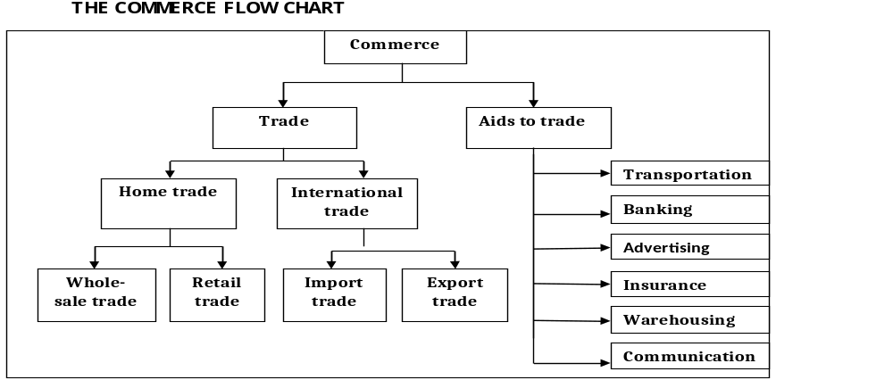
15 Ticks @ 0.7 mark = Total (10 marks)

- Costs of production;
- Total variable costs = woods to manufacture tables + wages for carpenters + electricity√
= 120,000 + 20,000 + 1,000
= TZS. 141,000. √
- Total fixed costs = wages for security guards+factory rent+supervisor’s salary+advertising costs√
= 5,000 + 5,000 + 4,000 + 2,000
= TZS. 16,000√
- Total costs = total variable costs + total fixed costs√
= 141,000 + 16,000
= TZS. 157,000. √
- Average Variable Cost = $\frac{total variable costs}{output }$ √
= $\frac{141,000}{1,000}$
= TZS.141 per output. √
- Average Total Cost = $\frac{total costs}{output }$ √
= $\frac{16,000}{1,000}$
= TZS. 16 per output√

10 ticks @ 01 mark = Total (10 marks)

- Organization of a bonded warehouse
- General administration
- Sales and advertising department
- Transports department
- Accounts department
- Legal department
- Purchases department. Any 5 points @ 2 marks = Total (10 marks)

- Features of capital
    - It is offered by human efforts
    - Its reward is interest
    - Capital is perishable factor
    - Is the most mobile factor
    - It is passive in nature
    - Its demand is derived
    - It is scarce in supply

Any 5 points @ 2 marks = Total (10 marks)
SECTION C (15 Marks)
- Ways of avoiding risks;
  - Mastered CCTV cameras.
  - Security guards and dogs.
  - Burglar alarms.
  - Advancing loans to credit worthy customers.
  - Fire extinguishers and fire detecting devices.
  - Fences around business environment such as schools.
Man body; any five points @ 3 marks = Total (15 Marks)

